Hedgehogs.net Website

Service studio Tutorials

Draft Version 1.1

Revision History
Version | Issue Date | Author | Description of Change
V1.0 | 16/11/09 | Sammy Kanan | Created
V1.1 | 17/11/09 |  | Added second tutorial

Introduction
This document covers how to use the Service studio of the Hedgehogs.net website.

Services are generally non visual components which return data on the basis of a number of input parameters. An example of a service is a calculation service to calculate price from yield (a derived data service) or to obtain some historical tic data (a reference data service). There is no technical reason why a service could not return a visualization, as a matter of fact a service can return anything, even binary data.

By making services available on the Hedgehogs.net platform, service providers can make use of the distribution network and make their services available to all users of the platform without having to target each one individually. Users can recommend services to one another thus extending the normal marketing reach. Additionally , anyone in the community can build on these in order to generate more specialized versions thus completing the supply chain.

Services can be defined by any user on Hedgehogs.net using the Service studio. A degree of technical knowledge is required in order to define a Service. Unlike widgets, services are actually not hosted on the Hedgehogs.net platform. Hedgehogs.net provides a proxy to these adding access controls in order to control distribution and availability to the community.

Hedgehogs.net
Service definition
Client
Request
to execute service
External service
Service provider
Request
to execute service

The client request and the request made by Hedgehogs.net to the external service do not have to be the same. Using the service definition the service provider can optionally add and rename parameters. Information returned from the external service is passed back to the client without any modifications.

Additional information can be found in the Hedgehogs.net Service studio Guide.

The tutorials all require the hosting of external services, to keep things “simple” we will make use of Google docs (http://docs.google.com/). This will be our service hosting platform as well as our “business logic” layer.

Pre-requisites – Google docs
As the tutorials all require the hosting of external services and Google docs will be used for this, you will need a Google account.

http://docs.google.com/

If you do not have a Google account please create one. You will need to sign into this and Hedgehogs.net.

The Service studio
In order to define and manage service definitions you have get to the Service studio tool set on Hedgehogs.net.

- Login to Hedgehogs.net
- Navigate from the top menu to ‘Tools’ and select ‘Studios’ from the drop down menu
- Once the Studios homepage has loaded, select ‘Service studio’ from the left hand side menu

Defining your first service - “Hello universe”
Our first tutorial is not “Hello world” but instead “Hello universe”, in this tutorial a CSV document is presented as a service containing a list of planets.

Creating the external service
The first step in making use of the Service studio to proxy a service is to have a service. Here we create a service using Google docs.

Step 1. Log in to Google docs (http://docs.google.com/).

Once logged in you will need to create a new document.

Step 2. Create new document by selecting “Create new” → “Spreadsheet”.

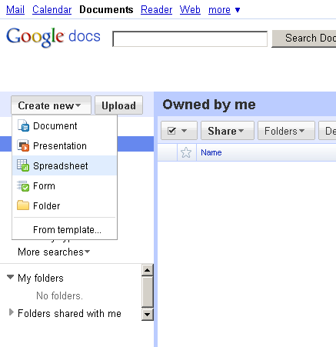

We will need to populate our spreadsheet with some data.

Step 3. Paste in the following document in the spreadsheet.

Name Diameter Mass
Mercury 0.382 0.06
Venus 0.949 0.82
Earth 1 1
Mars 0.532 0.11
Jupiter 11.209 317.8
Saturn 9.449 95.2
Uranus 4.007 14.6
Neptune 3.883 17.2

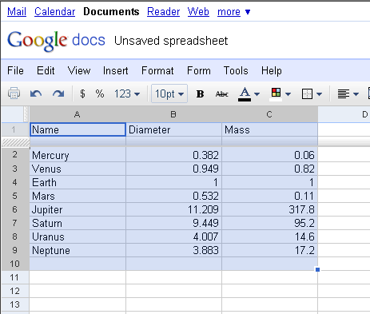

Details courtesy of Wikipedia (http://en.wikipedia.org/wiki/Planet).

Step 4. Save the spreadsheet with the name “planets”.

We now need to make this available externally.

Step 5. Select “Share” → “Publish as web page” (the share button is on the top hand right site of the spreadsheet).

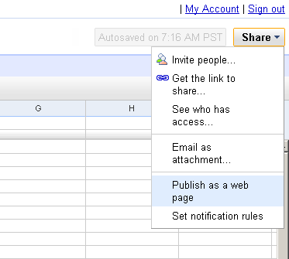

Step 7. Start publishing by pressing the “Start publishing button”.

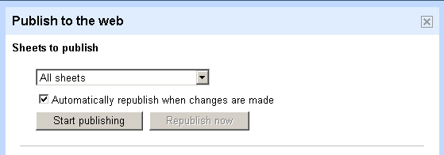

Note that the second half of the form now appears populated

Step 8. Set the values as displayed below (the range should be set to A1:A9).

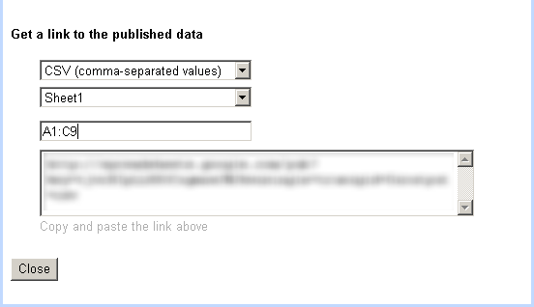

Step 9. Take a note of the URL in text are of the form (opaque area shown above), this will be the URL used for the external service.

The URL will be something like:

http://spreadsheets.google.com/pub?key=tjvrBIpLL8SOCxgmnwJMJkw&single=true&gid=0&range=A1%3AC9&output=csv

The value for the key will be different.

Congratulations, you have now created an external service! Now we have to expose this from the Hedgehogs.net site.

Getting to the Service studio

First you have get to the Service studio tool set on Hedgehogs.net.

Step 10. Login to Hedgehogs.net.

Step 11. Navigate from the top menu to ‘Tools’ and select ‘Studios’ from the drop down menu

Once the Studios homepage has loaded.

Step 12. Select ‘Service studio’ from the left hand side menu.

Creating a service
From the Service studio select the “Add service definition” from the left hand side menu. At this point you are presented with the Service studio definition form.

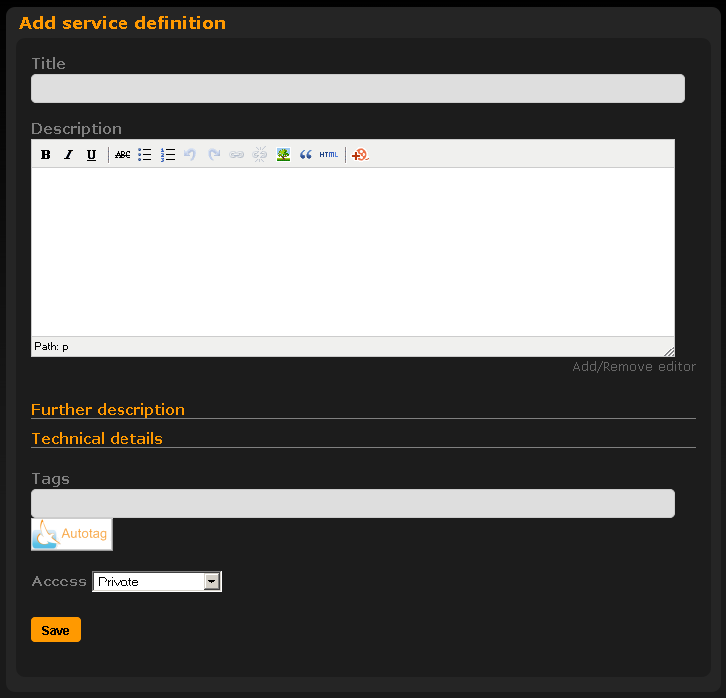

Basic service description
The first information you are prompted to provide is basic information about the service, this includes the
- a title (required) and
- an optional longer description.

This information is displayed to anyone who views the detailed service description.

Step 13. Enter “Hello universe” as the title.

Step 14. Enter “My first hello universe service” as the description. The description can contain rich text and images.

Technical details
Open the technical details section of the form.

Step 15.Click on the “Technical details” link.

You are prompted to provide the Source Service URL, the Request method, any user editable attributes and whether the service requires the client authorization token.

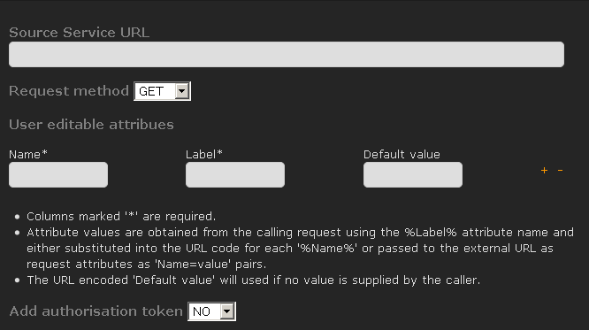

Step 16. In the Source Service URL section paste in the URL obtained from Step 9.

e.g. http://spreadsheets.google.com/pub?key=tjvrBIpLL8SOCxgmnwJMJkw&single=true&gid=0&range=A1%3AC9&output=csv

Ensure that the Request method is set to “GET”.

Tags
Tags can be provided in order to better categorize the service and make it more likely to be found when users are searching for content.

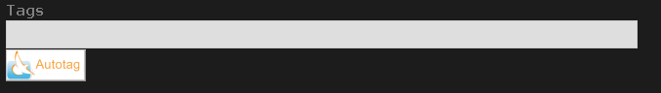

Step 17. Enter some tags which best describe your service say, “Hello universe, test, service”

By pressing the auto tag button the system will try and add to your tags any additional standard tags it can derive from the service description.

Access control
User defined service support the standard Hedgehogs.net access controls allowing the limitation of distribution of the widget to anyone you like; individuals, your user collections, groups or even keeping the service private.
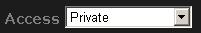

Step 18. For this tutorial we will set the access to private so that no one else can see or use this service.

Saving the service
Step 19. Clicking the save “Save” button from the bottom of the form will save the service.


You will be informed that the service has been saved and shown the details of the service.

Service details
The service details are displayed after saving a service definition or when selecting a service definition from content lists within the site.

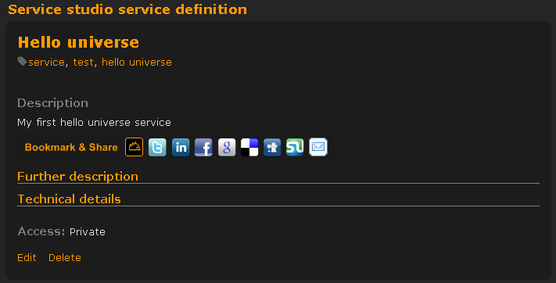

As this service is private it will not show in anyone's content lists but your own.

From this detailed view you can now open the service in a new window.

Step 20. Click on the “Technical details” link.

Step 21. Click on the “Click here” to execute the service ….

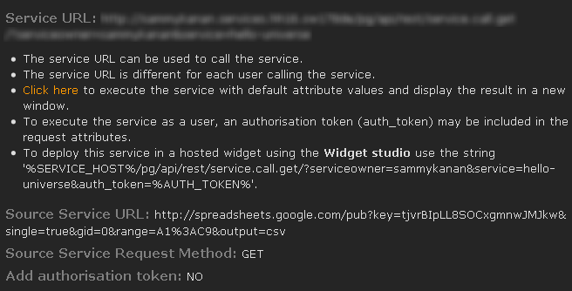

A new window will open displaying the service results in the same manner as it would be provided were it to be called from a client. In this case you will be prompted to save the results as a file as the results are text, but using the same mechanism a client application could interpret the result and use these for either another data result or a visualization.

Step 22. Save the file and check the contents. You should see that it contains all the planets.

As the owner of the service you can view more details than clients of the service. No external service attributes are disclosed to any client.

From the service detail the service can be edited or deleted.

If the service is deleted all references to it are lost, anyone using the service will end up with an error.

Viewing your Service studio definitions
In order to view your service definitions, go to the Service studio by:

- Navigate from the top menu to ‘Tools’ and select ‘Studios’ from the drop down menu
- Once the Studios homepage has loaded, select ‘Service studio’ from the left hand side menu

You are automatically taken to the list of your service definitions.

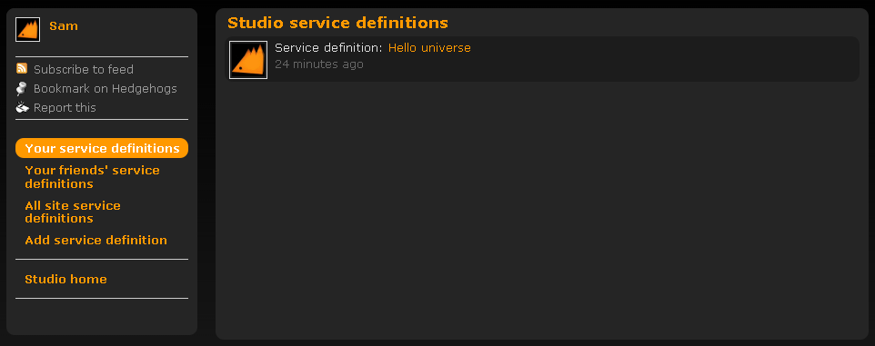

For each definition basic summary information is shown. The owner profile picture, service title and how many comments (if any) as well as when the service was created are shown here.

If you have many service definitions you can page through them.

To view the service detail, select the service title e.g. “Hello universe”.

End of the “Hello universe” tutorial
Congratulations, you have reached the end of the “Hello universe” tutorial. You should now know how to navigate around the system and add, edit and delete service definitions.

Using user editable attributes - “Hello earth”
In this tutorial we add user editable attributes to an existing service, particular reference is taken to the “Hello universe” service in the previous tutorial. You will need to set up the external service as described in section 4.1 Creating the external service.

User editable attributes allow a client to pass in parameters in order to control the service. In this tutorial we will extract a single planet from the spreadsheet using cell references. These can be passed in at execution time by the client.

Initially you have get to the Service studio tool set on Hedgehogs.net.

- Login to Hedgehogs.net
- Navigate from the top menu to ‘Tools’ and select ‘Studios’ from the drop down menu
- Once the Studios homepage has loaded, select ‘Service studio’ from the left hand side menu

Viewing your Service studio definitions
After having selected the “Service studio” from the Studios left hand side menu you are automatically taken to the list of your service definitions.

For each definition basic summary information is shown. The owner profile picture, service title and how many comments (if any) as well as when the service was created are shown here.

If you have many service definitions you can page through them.

Step 1. To view the service detail, select the service title e.g. “Hello universe”.

Editing “Hello universe”
Having selected the “Hello universe” service you are presented with the detailed view.

Step 2. To edit the service, select the “edit” option at the bottom of the detail.

Adding user editable attributes
Having selected to edit the service, you are presented with the service definition form
.
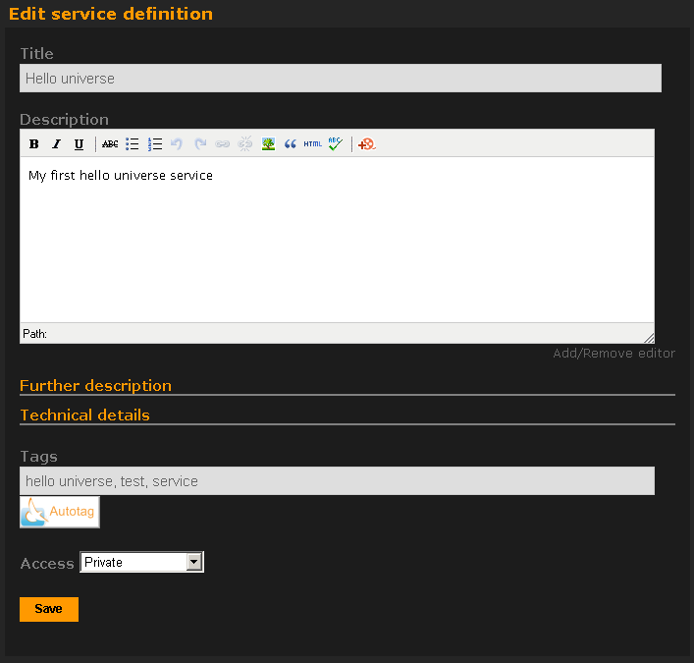

Step 3. Open the technical details section of the form by clicking on the “Technical details” link.

The technical details are shown.

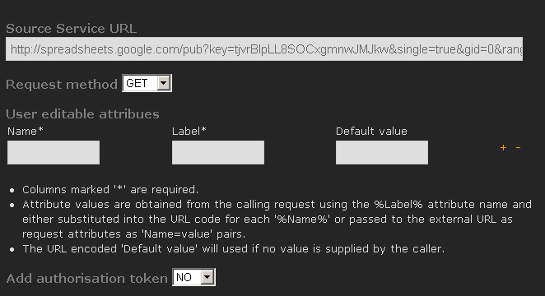

Adding user editable attributes
To add user editable attributes, simply fill in the form shown. In this example we will set up two new attributes, named CELL1 and CELL2, the client will be able to refer to these as FROM_CELL and TO_CELL and they will have default values of A1 and C9 respectively.

To add or remove user editable attributes use the + and – links at the end of each attribute line. The form will not allow you to remove the last attribute. To clear out all your attributes remove any text in the last row in your form.

Step 4. Enter the data in the form as below, creating a new attribute row using the + link.

Name | Label | Default value
CELL1 | FROM_CELL | A1
CELL2 | TO_CELL | C9

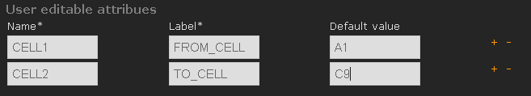

The URL now has to reference these attribute names. To do this the source URL has to be modified.

Modifying the Service Source URL to reference attributes
To make use of user editable attributes the Service Source URL must be modified to reference these by name.

Step 5. In order to do this modify the URL from something like:

http://spreadsheets.google.com/pub?key=tjvrBIpLL8SOCxgmnwJMJkw&single=true&gid=0&range=A1%3AC9&output=csv

to something like:

http://spreadsheets.google.com/pub?key=tjvrBIpLL8SOCxgmnwJMJkw&single=true&gid=0&range=%CELL1%%3A%CELL2%&output=csv

Note that we have changed the URL replacing the query string parameter A1 and C9 to read %CELL1% and %CELL2% respectively.
Step 6. Save the service
You will be informed that the service has been saved and shown the details of the service.

Executing the updated service
From the service detailed view open the technical details.

Step 7. Copy the Service URL and paste this into a new window.

You will be prompted to save the results as a file as the results are text, but using the same mechanism a client application could interpret the result and use these for either another data result or a visualization.

Step 8. Save the file and check the contents. You should see that it contains all the planets.

The URL will be something like:

http://testuser.services.hedgehogs.net/pg/api/rest/service.call.get/?serviceowner=testuser&service=hello-universe

Note that we have supplied no parameters to the service.

We now add the two labeled attributes FROM_CELL and TO_CELL to the URL with the values A4 and C4 respectively.

The URL should read something like:

http://testuser.services.hedgehogs.net/pg/api/rest/service.call.get/?serviceowner=testuser&service=hello-universe&from_cell=A4&to_cell=C4

Step 9. Copy the Service URL and paste this into a new window.

You will be prompted to save the results as a file again.

Step 10. Save the file and check the contents. You should see that it contains only the planet earth.

The parameters were taken from the client provided URL and transferred to the external service URL during execution. As a consequence the results are different.

End of the “Hello earth” tutorial
Congratulations, you have reached the end of the “Hello earth” tutorial. You should now know how to set user editable attributes and understand their effect on executing an external service.

Final notes on user editable attributes
User editable attributes are a key feature of the Service studio. These can be used to control almost any feature of an external service from providing simple numbers to be added to more complex structured documents.

Any value can be passed through the service definition to the external service, it is not limited to text. Using the HTTP POST method Web services can be called with XML payloads or even binary data can be sent.

