Hedgehogs.net Website

Licensing Tutorials

Draft Version 1.1

Revision History
Version | Issue Date | Author | Description of Change
V1.0 | 23/02/10 | Rob Hall | Created
V1.1 | 25/02/10 | Sammy Kanan | Minor updates

Sections

1. Introduction 4
2. Create some content (a media file) to license 4
2.1 Upload media (a file) 4
2.1.1 Select a File 4
2.1.2 Supply the title and description 5
2.1.3 Tags 5
2.1.4 Access control 5
2.1.5 Save 6
3. Defining a Simple License 7
3.1 Define a License 7
3.1.1 License definition 7
3.1.2 Tags 7
3.1.3 Access control 8
3.1.4 Terms and Conditions 8
3.1.5 License Charge 8
3.1.6 Saving the License 8
3.2 License the content 9
3.2.1 Edit the Media file 9
3.2.2 Change the access setting 9
3.2.3 Enable Content Licensing 9
3.2.4 Supply the teaser 9
3.2.5 Select the license(s) 10
3.2.6 Save 10
4. Defining a simple paid-for/chargeable License 11
4.1 Define a License 11
4.1.1 License definition 11
4.1.2 Tags 11
4.1.3 Access control 12
4.1.4 Terms and Conditions 12
4.1.5 License Charge 12
4.1.6 Address 13
4.1.7 Supply on behalf of a business 13
4.1.8 Tax 13
4.1.9 Accepted Currencies 14
4.1.10 Pricing Currency 14
4.1.11 Manage Periods 15
4.1.12 Saving the License 15
5. Defining a more complex paid-for License 16
5.1 Define a License 16
5.1.1 License definition 16
5.1.2 Tags 16
5.1.3 Access control 17
5.1.4 Terms and Conditions 17
5.1.5 License Charge 17
5.1.6 Address 18
5.1.7 Supply on behalf of a business 18
5.1.8 Tax 18
5.1.9 Accepted Currencies 19
5.1.10 Pricing Currency 19
5.1.11 Manage Periods 20
5.1.12 Saving the License 21

Introduction
This document covers how to use the Licensing features of the Hedgehogs.net website.

A License allows a user to define the conditions under which they will license access to their content such as blog entries, uploaded files etc. The license conditions are set by the licensor (the license issuer) and when another user wishes to access the content covered by a license, they must accept the terms and conditions of the license. This feature is available to all Hedgehogs.net members.

Licenses can do a number of things such as restricting or granting rights to the licensee (the license consumer) to use the content in certain ways. They also allow the licensor to define a fee that licensees must pay and the terms of the payment, i.e. single one off or subscription based payments.

Create some content (a media file) to license

In order to complete any of the tutorials, you will need some content to license. If you already have content on Hedgehogs.net that you want to license then you can skip this step. If you don't have any content that you want to license or you just want to test the licensing feature without restricting access to any of your other content, then you need to complete this section.

Upload media (a file)
In this example we will upload a file, but we could create another type of licenseable content such as a blog, or a data service.

Select the Media tool from the Tools menu at the top of the screen. Now select the Upload Media option from the menu on the left side.

Select a File

The first field allows you to select the file that you are going to upload, this could be a PDF, word document, audio file etc.

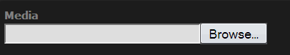
Click on the Browse button and locate the first that you wish to license from your hard drive.

Supply the title and description

The next two fields in this feature allow you to supply a title for the file and a description. Note that the description can be HTML.

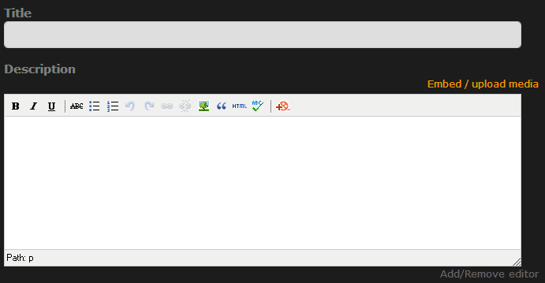

Enter “My Test File” as the title and 'This is the description of my test file.' in the description field.

Tags
Tags can be provided in order to better categorize the file and make it more likely to be found when users are searching for content.

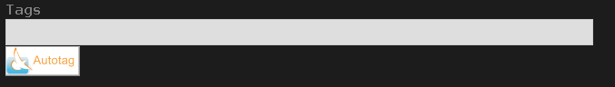

Enter some tags which best describe your file say, 'test, file'

Access control
Media supports the standard Hedgehogs.net access controls allowing the limitation of distribution of the content to anyone you like; individuals, your user collections, groups or even keeping the media file private. We shall be setting the access control to the value of Private for now to ensure that other users don't see it before it is licensed.

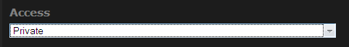

Select the access control group Private.

Save
We now need to save the file.
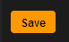
Click on the Save button.

That's it, the file is now ready for licensing using any of the license tutorials.

Defining a Simple License
The first tutorial will cover licensing a Media file with a simple license.

Having logged in and selected the 'Licensing' tool, select 'Licensor's View' from the menu on the left side of the screen.

Define a License
Select the 'Add License' option from the menu on the left side of the screen.

License definition
The first information you are prompted to provide is basic information about the License, this includes the
- a title (required) and
- an optional longer description.

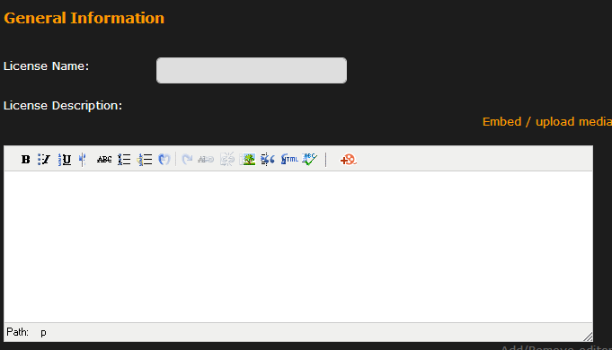

This information is displayed to anyone who views the detailed license description.

Step 1. Enter “My First License” as the title.

Step 2. Enter “My first hedgehogs.net license” as the description. The description can contain rich text and images.

Tags
Tags can be provided in order to better categorize the license and make it more likely to be found when users are searching for content.

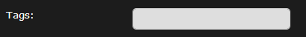

Step 3. Enter some tags which best describe your license say, “test, license”

Access control
Licenses support the standard Hedgehogs.net access controls allowing the limitation of distribution of the license to anyone you like; individuals, your user collections, groups or even keeping the license private.

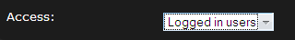

For this tutorial we will set the access to 'Logged in Users' so that others can see this license.

Terms and Conditions
This field is where the licensor can specify the terms and conditions of their license. You can either enter the text of the license as normal text or paste the HTML link to a license which is described elsewhere, e.g. a web page on your site.

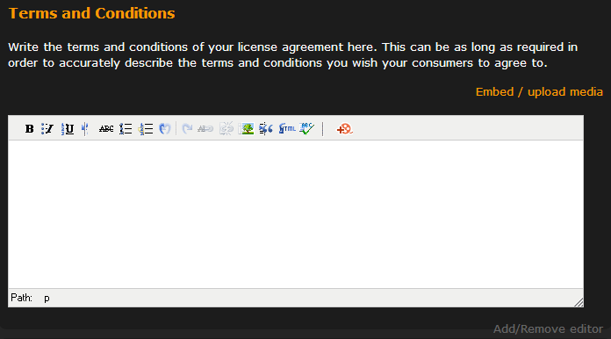

For this tutorial we will set the Terms and Conditions to 'None'.

License Charge
This option allows you to define whether to charge for the license or not.

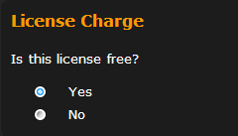

Since this is the simple license tutorial, we'll leave the option set to 'Yes' indicating that the license is not chargeable, licensees will have to agree to the license terms and conditions but will not incur a charge.

Saving the License

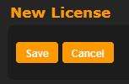
All the information for the simple license is now complete, so we need to save the license. This is done by clicking on the save button, at either the top or bottom of the screen.
Click on the Save Button

License the content

Now we will go back and edit the Media file so that it's included in the license.

Edit the Media file

Select the Media tool from the Tools menu at the top of the screen. Now click on the title of the file that you created in the first step.

Now click on the Edit link
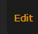

Change the access setting

To enable other users to see that your file exists we need to set the access control to something other than private. For the purposes of this tutorial we will use the setting 'Logged in users'.

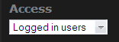
Set the Access option to Logged in users

Enable Content Licensing

The following check box determines whether the content is licensed or not.
Tick the Enable content licensing check box.

Supply the teaser
The teaser is a piece of content which will be displayed to users who are not licensed instead of the content. It's aim is to help the user understand what the content is without allowing them access to it.

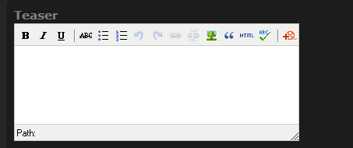
Enter the text 'This is my file'.

Select the license(s)
All of your licenses should be listed on the screen, including the one we just created.

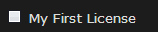
Tick the My First License check box.

Save
Now save the file again, by clicking on the Save button.

That's it, the content is now licensed. Users who encounter the file will now only see the teaser and in order to view the full content, the must obtain a license agreement for the new license.

Defining a simple paid-for/chargeable License

This tutorial will cover the creation of a paid-for license. A prerequisite for this is to complete Section 2. Create some content to license

Having logged in and selected the 'Licensing' tool, select 'Licensor's View' from the menu on the left side of the screen.

Define a License
Select the 'Add License' option from the menu on the left side of the screen.

License definition
The first information you are prompted to provide is basic information about the license, this includes the
- a title (required) and
- an optional longer description.

This information is displayed to anyone who views the detailed license description.

Step 1. Enter “My Simple License” as the title.

Step 2. Enter “My simple hedgehogs.net license” as the description. The description can contain rich text and images.

Tags
Tags can be provided in order to better categorize the license and make it more likely to be found when users are searching for content.

Step 3. Enter some tags which best describe your license say, “test, license”

Access control
Licenses support the standard Hedgehogs.net access controls allowing the limitation of distribution of the license to anyone you like; individuals, your user collections, groups or even keeping the license private.

For this tutorial we will set the access to 'Logged in Users' so that others can see this license.

Terms and Conditions
This field is where the licensor can specify the terms and conditions of their license. You can either enter the text of the license as normal text or paste the HTML link to a license which is described elsewhere, e.g. a web page on your site.

For this tutorial we will set the Terms and Conditions to 'None'.

License Charge
This option allows you to define whether to charge for the license or not.

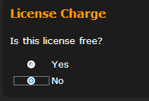
Select No for this option.

Address

As the licensor you need to supply an address if you create a license which involves payment. If you've already added any addresses, they will be displayed. If no addresses are listed click on the Add Address and complete the address form, finishing by clicking Save Address

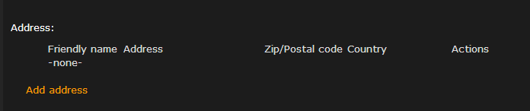

Supply on behalf of a business

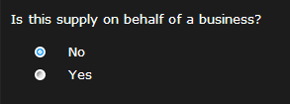

This option refers to whether or not the licensing of the content is on behalf of a business or in a personal capacity. For the purposes of this tutorial, select No.

Tax

Hedgehogs.net allows you to specify your VAT details as part of a license in order to correctly collect VAT during payment by the licensee. Since this is the simple paid-for license we will not use the VAT feature.

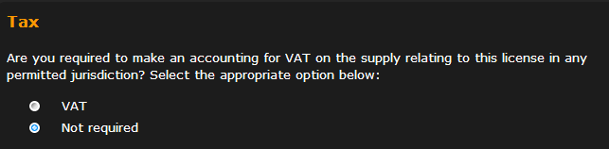
Select Not Required

In the VAT Not Required section below, tick the Not required to collect taxes for another reason e.g. below the VAT threshold option.

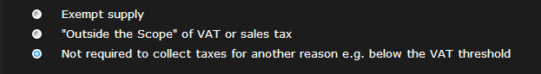

Accepted Currencies

You can choose the currencies that you wish to accept as payment for the license. You must select at least one currency. The licensee will be able to choose from the currencies you select.

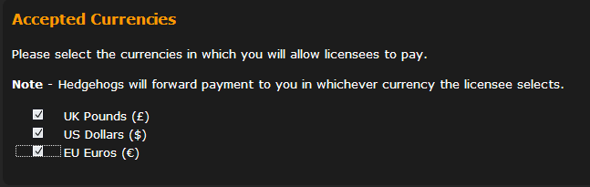

Tick the all three options.

Hedgehogs.net will pay you in the same currency as any licensee pays/that you are willing to accept so it is important to select only the currencies for which you can receive monies in.

Pricing Currency

You can select the currency in which you will set the price of your license. The pricing currency must be one of the selected Accepted Currencies.

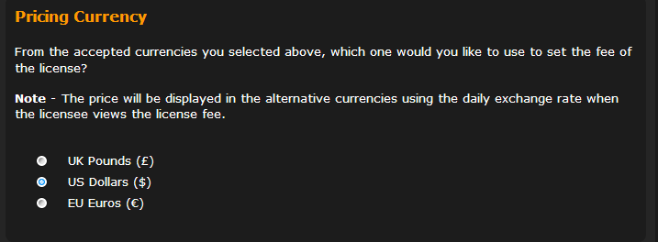
Tick the US Dollars ($) option

Manage Periods

Periods are how you define how much your license costs. Since this is the simple paid-for license we'll define a one off payment for 1 year of access.

Click on the Add Period link:

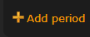
Type '1 year of Access' in the name field

Select a Duration of 1

Select a Period of Year

Select a frequency of 1

Enter '10.00' in the Net Fee box

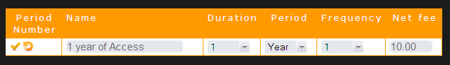
Now Click on the icon to Save the Period

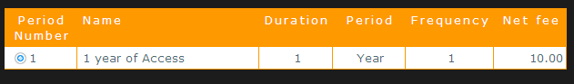

This will result in a single charge for one year of access for 10 US Dollars.

Saving the License

All the information for the simple license is now complete, so we need to save the license. This is done by clicking on the save button, at either the top or bottom of the screen.
Click on the Save Button

Defining a more complex paid-for License

This tutorial will cover the creation of a paid-for license with complex payments. A prerequisite for this is to complete Section 2. Create some content to license

Having logged in and selected the 'Licensing' tool, select 'Licensor's View' from the menu on the left side of the screen.

Define a License
Select the 'Add License' option from the menu on the left side of the screen.

License definition
The first information you are prompted to provide is basic information about the license, this includes the
- a title (required) and
- an optional longer description.

This information is displayed to anyone who views the detailed license description.

Step 1. Enter “My more complex License” as the title.

Step 2. Enter “My more complex hedgehogs.net license” as the description. The description can contain rich text and images.

Tags
Tags can be provided in order to better categorize the license and make it more likely to be found when users are searching for content.

Step 3. Enter some tags which best describe your license say, “test, license”

Access control
Licenses support the standard Hedgehogs.net access controls allowing the limitation of distribution of the license to anyone you like; individuals, your user collections, groups or even keeping the license private.

For this tutorial we will set the access to 'Logged in Users' so that others can see this license.

Terms and Conditions
This field is where the licensor can specify the terms and conditions of their license. You can either enter the text of the license as normal text or paste the HTML link to a license which is described elsewhere, e.g. a web page on your site.

For this tutorial we will set the Terms and Conditions to 'None'.

License Charge
This option allows you to define whether to charge for the license or not.

Select No for this option.

Address

As the licensor you need to supply an address if you create a license which involves payment. If you've already added any addresses, they will be displayed. If no addresses are listed click on the Add Address and complete the address form, finishing by clicking Save Address

Supply on behalf of a business

This option refers to whether or not the licensing of the content is on behalf of a businsess or in a personal capacity. For the purposes of this tutorial, select No.

Tax

Hedgehogs.net allows you to specify your VAT details as part of a license in order to correctly collect VAT during payment by the licensee. In this tutorial we will not use the VAT feature.

Select Not Required

In the VAT Not Required section below, tick the Not required to collect taxes for another reason e.g. below the VAT threshold option.

Accepted Currencies

You can choose the currencies that you wish to accept as payment for the license. You must select at least one currency. The licensee will be able to choose from the currencies you select.

Tick the all three options.

Hedgehogs.net will pay you in the same currency as any licensee pays/that you are willing to accept so it is important to select only the currencies for which you can receive monies in.

Pricing Currency

You can select the currency in which you will set the price of your license. The pricing currency must be one of the selected Accepted Currencies.

Tick the US Dollars ($) option

Manage Periods

Periods are how you define how much your license costs. Periods run consecutively. In this tutorial we will have an free introductory period of 10 days followed by a regular monthly fee of 10 US Dollars for 12 months.

Click on the Add Period link:

Type 'Introductory Period' in the name field

Select a Duration of 10

Select a Period of Days

Select a frequency of 1

Enter '0' in the Net Fee box

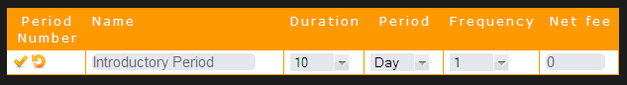

Now Click on the icon to Save the Period

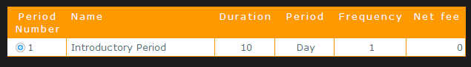

Click on the Add Period link:

Type 'Monthly Charge' in the name field

Select a Duration of 1

Select a Period of Month

Select a frequency of 12

Enter '10.00' in the Net Fee box:
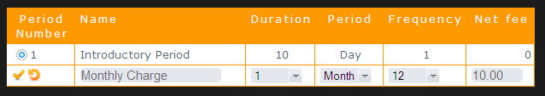
Now Click on the icon to Save the Period

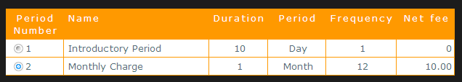

Saving the License

All the information for the simple license is now complete, so we need to save the license. This is done by clicking on the save button, at either the top or bottom of the screen.
Click on the Save Button

This license is no available to other users. They will pay nothing for 10 days, after which they will pay 10 US Dollars every month for 12 months of access.

